ABATE of Washington
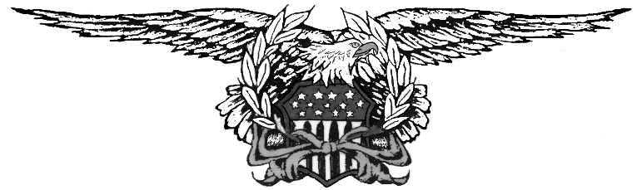
Press Release
Gun Raffle 2023

As most of you know, the State of Washington has outlawed the sale and transfer of high-capacity magazines and semi-automatic guns. Whether you agree or disagree this is where we are at. The top two guns in our raffle can no longer be raffled off. I have contacted the State Gambling commission and they understand the situation we are faced with.
Therefore, here are the changes we are making for this raffle. First, anyone that requests their money back for the tickets they have purchased for the gun raffle will be refunded as long as they can produce their ticket stubs, and this must be done PRIOR to the raffle taking place.
Second, the top two prizes that we cannot transfer, or award will now be cash prizes for the value of the guns at the price we were guaranteed to purchase them at:
1st Prize: Tommy Gun Model 1927A 45ACP $ 2,300.00
2nd Prize: CZ Scorpion EVO 3 OD 9mm Pistol $ 850.00
If you have any questions regarding this, please let me know and no, I cannot change the laws.
Andy McAfee Scott Robinson
State Coordinator Spring Opener Committee Chair

